WEEK 8
Week Ending: 24-10-2025 | DAY: |  | Subject: Computing
Duration: 50mins |  |  | Strand: Productivity Software
Class: B8 | Class Size: |  | Sub Strand: Introduction to Presentation
Content Standard:  B82.2.1 Demonstrate how to use Microsoft PowerPoint (Multimedia) |  | Indicator:  B8.2.2.1.1. Demonstrate how to add pictures, screenshot and edit and format pictures |  |  |  |  | Lesson:  1 of 2
Performance Indicator:  Learners can demonstrate how to add pictures, screenshot and edit and format pictures. |  |  |  | Core Competencies:  Communication and Collaboration, Critical Thinking and Problem solving
Reference: Computing Curriculum P.g. 29
Activities For Learning & Assessment |  |  |  |  | Resources | Progression
Starter (5mins)  Revise with learners to review their understanding in the previous lesson.  Share performance indicators and introduce the lesson.  Main (35mins)  Revise with learners on the use of the PowerPoint presentation application.  - PowerPoint is easy to use and has a user-friendly interface that enables users to create engaging presentations quickly.  - PowerPoint is versatile in that it can be used for various purposes, including business presentations, educational lectures, and personal projects.  - PowerPoint presentations can help to enhance communication by presenting information in a clear and concise manner, and by incorporating visual aids that help to convey complex information more easily  Let learners identify and discuss the features of the PowerPoint presentation window.  - Title Bar: The title bar displays the name of the current presentation and allows you to minimize, maximize, or close the PowerPoint window.  - Ribbon: The Ribbon is the main toolbar that contains various tabs, such as Home, Insert, Design, Transitions, Animations, etc., with each tab containing related groups of tools that allow you to perform various tasks in PowerPoint.  - Quick Access Toolbar: The Quick Access Toolbar provides quick access to frequently used commands, such as Save, Undo, and Redo.  - Slides Pane: The Slides pane displays all the slides in the current presentation, and allows you to add, delete, and rearrange slides as needed.  - Notes Pane: The Notes pane allows you to add speaker notes that only you can see during a presentation.  - Slide Area: The Slide Area is the main working area where you can create and edit your slides.  - Status Bar: The Status Bar displays information about the current slide, such as the slide number and the view that you are currently using.  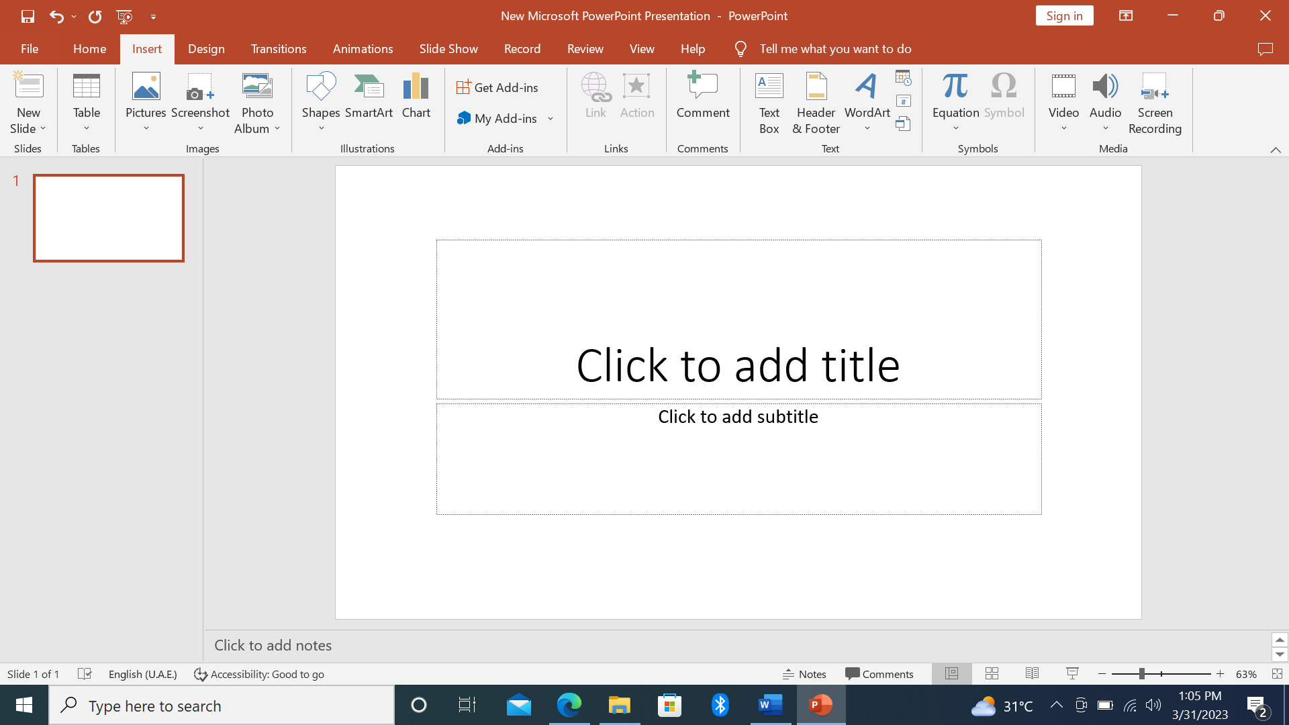  Guide learners to explore the use of the Images Group under the Insert tab.  - Pictures: this allows you to add pictures from your computer, stock image library or from online source.  - Screenshot: allows you to add a snapshot of any window that’s open on the desktop to your document.  - Photo Album: It allows you to create a beautiful presentation for your favorite photo collection.  Learners in groups demonstrate the use of ClipArt, Photo Album and Screenshot.  Project examples of the PowerPoint interface to learners with the aid of a projector or pictures.  Reflection (10mins)  Use peer discussion and effective questioning to find out from learners what they have learnt during the lesson.  Take feedback from learners and summarize the lesson. |  |  |  |  | Pictures and videos

Week Ending: 24-10-2025 | DAY: |  | Subject: Computing
Duration: 50mins |  |  | Strand: Productivity Software
Class: B8 | Class Size: |  | Sub Strand: Introduction to Presentation
Content Standard:  B82.2.1 Demonstrate how to use Microsoft PowerPoint (Multimedia) |  | Indicator:  B8.2.2.1.1. Demonstrate how to add pictures, screenshot and edit and format pictures |  |  |  |  | Lesson:  1 of 2
Performance Indicator:  Learners can identify different methods for adding and capturing pictures in PowerPoint |  |  |  | Core Competencies:  Communication and Collaboration, Critical Thinking and Problem solving
Reference: Computing Curriculum P.g. 29
Activities For Learning & Assessment |  |  |  |  | Resources | Progression
Starter (5mins)  Show students engaging and visually appealing presentations utilizing pictures effectively.  Ask them what makes these presentations stand out and how pictures contribute to their impact.  Share performance indicators and introduce the lesson.  Main (35mins)  Project an image of the PowerPoint Insert tab and highlight the Images Group. Explain the functions of each option: ClipArt, Pictures from File, Online Pictures, Photo Album, and Screenshot.  Discuss the advantages and limitations of each source.  Briefly demonstrate how to search for and insert ClipArt images into a presentation.  Emphasize copyright considerations and choosing appropriate ClipArt.  Share a pre-selected Photo Album or guide students through creating their own. Showcase how photo albums can add a personal touch to presentations.  Demonstrate proper techniques for taking screenshots using dedicated tools (e.g., Windows Snipping Tool, macOS Command+Shift+4).  Discuss ethical considerations for capturing screenshots and respecting privacy.  Divide students into pairs or small groups and assign them a presentation topic (e.g., favorite book, future career, local landmark). Encourage them to choose images from various sources within the Images Group, considering appropriateness and copyright.  Guide students through basic image editing tools within PowerPoint (e.g., cropping, resizing, rotating, adjusting brightness and contrast). Teach them formatting techniques like size, position, alignment, and borders.  Allow students time to work on their presentations, incorporating pictures, editing them, and formatting them effectively.  Assessment  Where in PowerPoint can you find options to insert different types of images?  Can you name two ways to add your own photos to a presentation using the Images Group?  Imagine you're making a presentation about animals. Would ClipArt or Online Pictures be a better choice for images? Why?  What tool in PowerPoint lets you capture a picture of your computer screen and insert it into your presentation?  Reflection (10mins)  Use peer discussion and effective questioning to find out from learners what they have learnt during the lesson.  Take feedback from learners and summarize the lesson. |  |  |  |  | Pictures and videos  Computers with internet access and presentation
Homework/Project Work/Community Engagement Suggestions
- Is it okay to use any picture you find online for your presentation without asking? Why or why not?
- True or False: Adding pictures always makes a presentation better.
- Think of a presentation you might give in the future. What kind of images would you use and how would you edit or format them to make them stand out?
- Can you imagine a career where using images effectively in presentations would be important? Give an example.

Week Ending: 24-10-2025 | DAY: |  | Subject: Computing
Duration: 50mins |  |  | Strand: Productivity Software
Class: B8 | Class Size: |  | Sub Strand: Introduction to Presentation
Content Standard:  B82.2.1 Demonstrate how to use Microsoft PowerPoint (Multimedia) |  | Indicator:  B8.2.2.1.2. Demonstrate how to add a drawing canvas, shapes, and also edit, format and add text to shapes |  |  |  |  | Lesson:  1 of 2
Performance Indicator:  Learners can demonstrate how to add a drawing canvas, shapes, and also edit, format and add text to shapes |  |  |  | Core Competencies:  Communication and Collaboration, Critical Thinking and Problem solving
Reference: Computing Curriculum Pg. 29
Activities For Learning & Assessment |  |  |  |  | Resources | Progression
Starter (5mins)  Revise with learners to review their understanding in the previous lesson.  Share performance indicators and introduce the lesson.  Main (35mins)  Explore the use of the Illustrations group under the Insert tab.  - Shapes: this allows you to insert ready made shapes, such as circles, squares and arrows.  - SmartArt: this allows to insert SmartArt graphics to visually communicate information.  - Chart: this allows you to insert graphs that makes easy to spot patterns and trends in your data.  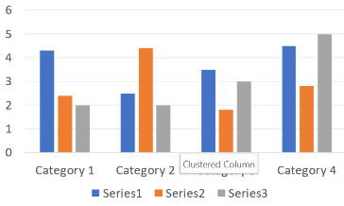  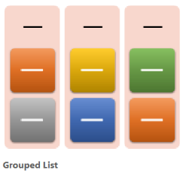  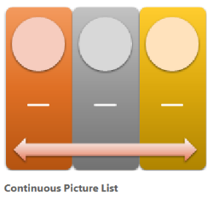  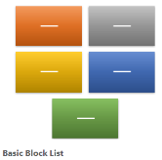  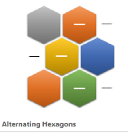  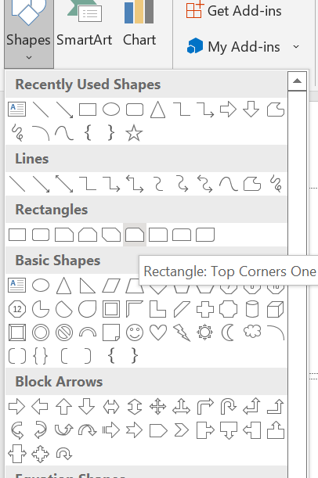  Engage learners to demonstrate the use of Shapes and SmartArt.  Explore the use of the drawing canvas to group shapes.  Reflection (10mins)  Use peer discussion and effective questioning to find out from learners what they have learnt during the lesson.  Take feedback from learners and summarize the lesson. |  |  |  |  | Pictures and videos
Homework/Project Work/Community Engagement Suggestions
State and explain the uses of five features of the PowerPoint presentation window
Cross-Curriculum Links/Cross-Cutting Issues
None
Potential Misconceptions/Student Learning Difficulties
None

Week Ending: 24-10-2025 | DAY: |  | Subject: Computing
Duration: 50mins |  |  | Strand: Productivity Software
Class: B8 | Class Size: |  | Sub Strand: Introduction to Presentation
Content Standard:  B82.2.1 Demonstrate how to use Microsoft PowerPoint (Multimedia) |  | Indicator:  B8.2.2.1.2. Demonstrate how to add a drawing canvas, shapes, and also edit, format and add text to shapes |  |  |  |  | Lesson:  1 of 2
Performance Indicator:  Learners can understand the advantages and applications of Shapes and SmartArt for various purposes. |  |  |  | Core Competencies:  Communication and Collaboration, Critical Thinking and Problem solving
Reference: Computing Curriculum Pg. 29
Activities For Learning & Assessment |  |  |  |  | Resources | Progression
Starter (5mins)  Show students examples of captivating presentations that creatively use illustrations beyond images.  Ask them what types of illustrations can be used (e.g., shapes, diagrams, charts) and how they can contribute to storytelling or information visualization.  Share performance indicators and introduce the lesson.  Main (35mins)  Project an image of the PowerPoint Insert tab and highlight the Illustrations group.  Explain the features of Shapes (basic geometric shapes and lines) and SmartArt (pre-designed diagrams and charts). Discuss the advantages and limitations of each.  Guide students through experimenting with Shapes in PowerPoint. Showcase diverse types of shapes, highlighting options for customization (color, fill, line style). Encourage creativity and exploration.  Demonstrate how to insert and customize SmartArt graphics. Showcase various categories (e.g., process diagrams, cycle diagrams, organizational charts) and explain their specific purposes.  Briefly introduce the drawing canvas within PowerPoint as a space for grouping and arranging shapes.  Illustrate basic grouping techniques for creating complex visuals.  Divide students into pairs or small groups and assign them a presentation topic (e.g., daily routine, scientific process, historical event). Encourage them to brainstorm and sketch illustrations (Shapes or SmartArt) that effectively represent their topic.  Guide students through incorporating their chosen illustrations into PowerPoint slides.  Teach them how to insert, edit, and position illustrations for optimal visual impact.  Assessment  - Where in PowerPoint can you find Shapes and SmartArt graphics?  - Imagine you need to explain a scientific process in your presentation. Which type of illustration would be more helpful, Shapes or SmartArt? Why?  - Can you name two ways to customize the appearance of a basic Shape in PowerPoint?  - True or False: SmartArt graphics are only good for making pie charts and bar graphs.  Reflection (10mins)  Use peer discussion and effective questioning to find out from learners what they have learnt during the lesson.  Take feedback from learners and summarize the lesson. |  |  |  |  | Pictures and videos, Computers with PowerPoint software installed
Homework/Project Work/Community Engagement Suggestions
- What is the drawing canvas in PowerPoint used for?
- Think about your favorite hobby or sport. How could you use Shapes or SmartArt to create a cool illustration about it?
- Why is it important to choose illustrations that are relevant to your presentation topic?
- Can you imagine a career where using Illustrations effectively in presentations would be important? Give an example.
Cross-Curriculum Links/Cross-Cutting Issues
None
Potential Misconceptions/Student Learning Difficulties
None

